Algae Estimator

Created by: Andrew Barrett, Asif Reza, Dominique Tipton, Michael Horning, Peter Langlois,

Qiao Li , and Waleed Saad

Page 1: Calculate

* There are six boxes for data entry, they are circled in red.
* The boxes that are white, the data can be typed in directly into the box. The other two grey boxes will change pages for the data entry.
* The question mark buttons that are circled in orange, give an in depth explanation on what the user needs to provide data need for the box next to it.
* Once all the boxes have been filled in with data, the blue circled submit button uses the data to make the predicted algae bloom. If any of the boxes have incorrect data entries, it will let the user know.
* The clear button circled in black clears all the data.
* The two buttons on the bottom circled in yellow switches between the two pages called Calculate and DataLog.
* When the grey boxes are clicked, it brings the user to another page to directly enter the data in or estimate it.

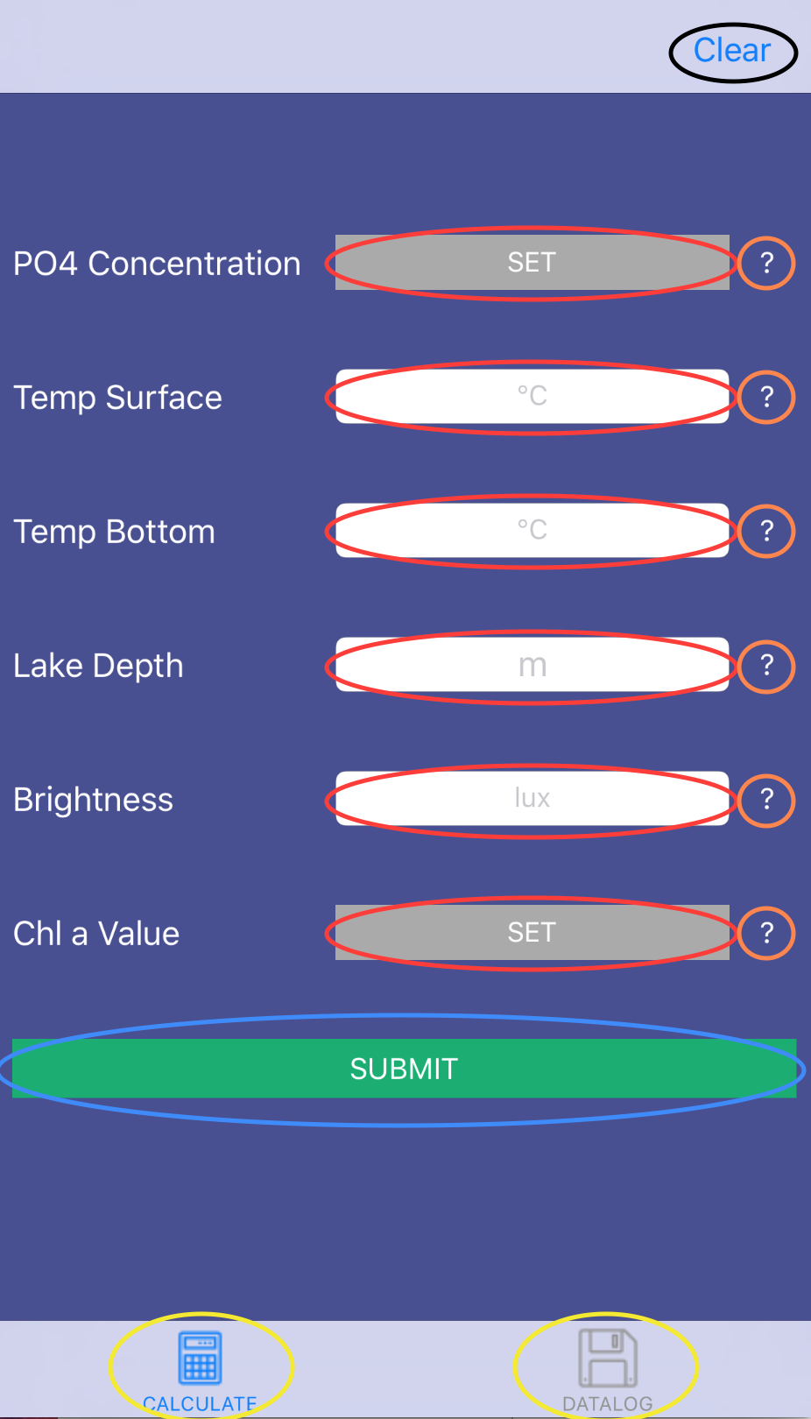

Left Picture:

* There are buttons and sliders circled in red are used to estimate how much phosphate might be in the water.
* The number circled in yellow is the current estimate from the buttons and sliders.
* The submit button circled in blue submits the current estimate.

Right Picture:

* The white box with the red circle is for the direct data.
* The question mark with the orange circle gives more info about PO4 Concentration
* The blue circle is the submit button which submits the data.
* The bottom buttons circled in yellow navigate between the two pages.

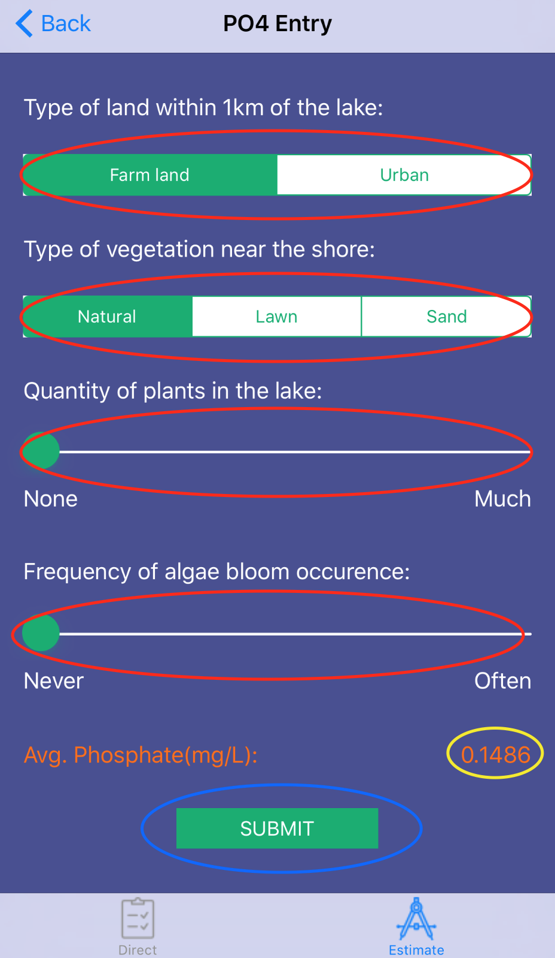 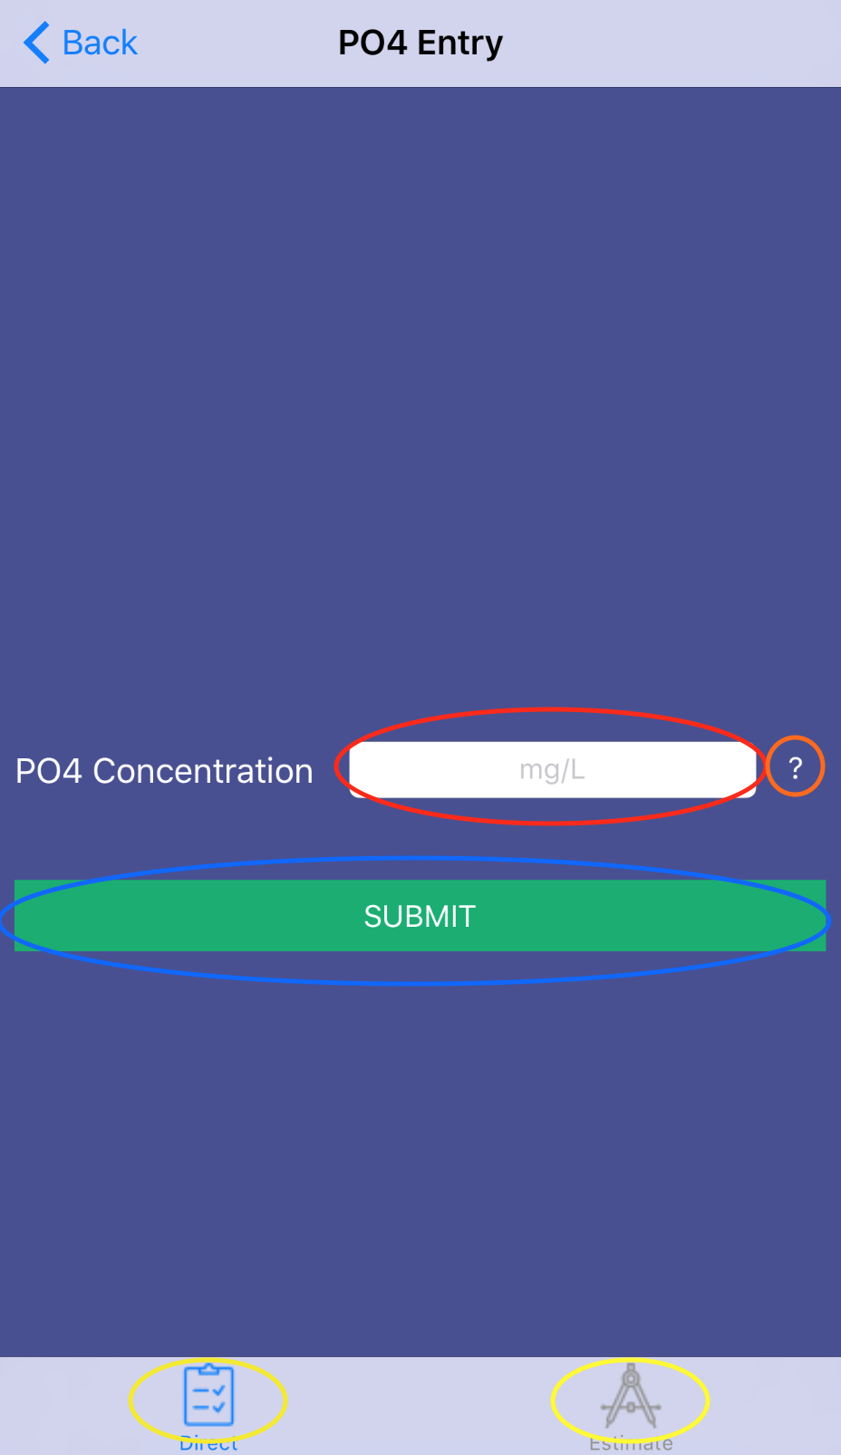

Left Picture: Direct Page

* The boxes in the yellow circle are for the data entry.
* The question mark circled orange gives more information about the Chl a.
* The green box circled in blue is the submit button, used for submitting data in the white boxes.
* The bottom yellow circles are the buttons for navigating between the two pages.

Right Picture: Estimate Page

* The boxes circled in red are for the data entry.
* The question mark circled in orange gives more information about secci depth and dissolved oxygen
* The green box circled in blue is the submit button, used for submitting data in the white boxes.

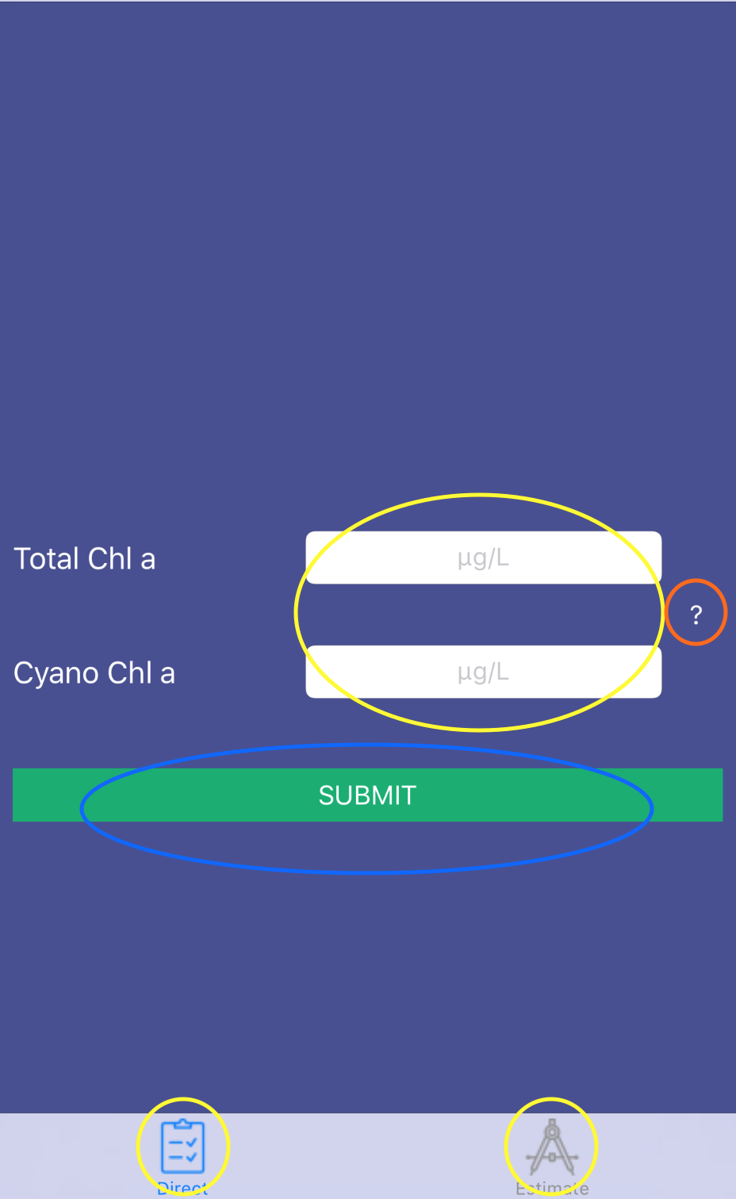 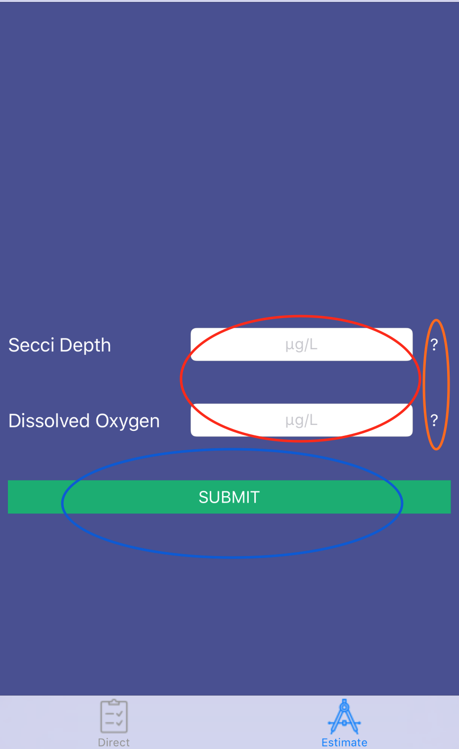

Page 2: DATALOG

* This page contains saved data entries and categorizes them by date then by time. The dates are circled in red.

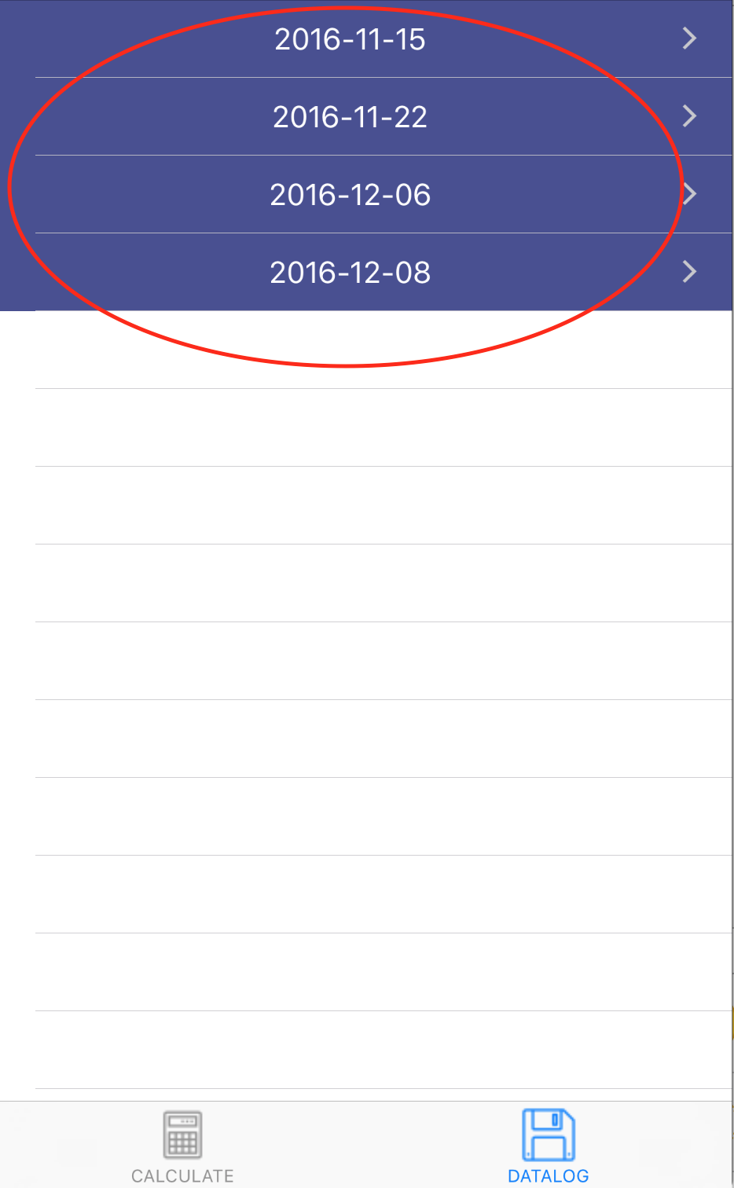

Page 3: Data

* The red circles are the data set and edit data set.
* The data set button shows every data point created from the algae prediction formula.
* The edit data set button edits past logged data.
* The yellow circles navigate between the two pages called DATA and GRAPH.
* The black circle creates a new log from scratch.

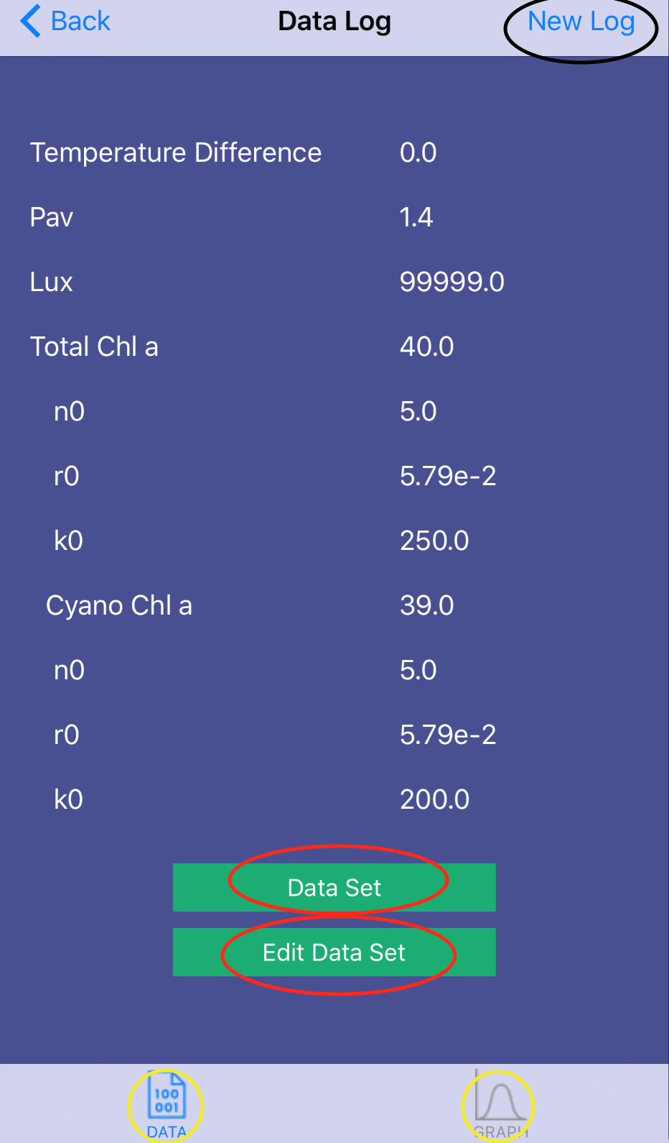

Page 4: Graph

* The graph page displays the data points from the algae prediction formula.
* The y-axis is Chl a concentration (μg/L).
* The x-axis is time in hours.
* The blue line is the total Chl a, the green Cyano Chl a, and the red line display where anything above the line is dangerous levels of algae.

